Girl Scouts Greater Los Angeles Web Site

Web Site Admin Instructions

Calendar Admin Instructions

Introduction:
The Girl Scouts Greater Los Angeles’s web site allows certain staff members to update information that is viewable by the general public on our web site, such as calendar events, documents, job postings, staff contact information, and on some pages web site content.

About The “Master Calendar”:
The “Master Calendar” displays various special events, office closures, and other events. Multiple people have the ability to edit the calendar. Please Note: this calendar is available to the public: do not post sensitive information like troop meeting locations and small private events.

Events, Sessions, and Meetings
Event
Session
Register
The Master Calendar has three classes of object to describe an event.
Meeting
Session
Events are the largest class. Events contain a title, description and other information that is common to all sessions and meetings.
Session
Sessions are the second largest class. Sessions are “register-able events.” An Event can have many different sessions. By creating one event with multiple sessions you can reuse the information contained in the Event for multiple sessions (register-able events).
Meeting
Register
Meeting
Meeting
Meeting
Register
Meeting

Meetings are the smallest class and contain information about the date(s) and time(s) on which a session occurs. A session that happens on one day will have only one meeting. A session that happens on multiple days (where only one registration is required) will have multiple meetings.
Session
Meeting
Register

Publish, Cancel, Review, Archive
The system is designed to allow many people to add and edit events. Sessions can be marked as published, un-published, canceled, un-canceled, reviewed, and archived. Administrators can change the status of a session and each status will cause the session to be viewed in a different way.

Publish/Un-publish
While a session is being created and edited, but not ready for public consumption, the session is hidden from public view (un-published), and only viewable by people who are logged in. New sessions and un-archived sessions are un-published by default. When the session is ready to be viewed by the public it can be published.

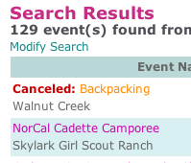
Cancel/Un-Cancel
When a session is canceled due to low enrollment or other extenuating circumstances, the session can be marked “canceled” in the Master Calendar. Marking a session as canceled does not remove it from the public calendar but adds a canceled message to the listing. Marking a session as canceled also removes the registration information from the public listing. Visitors cannot register for a canceled session.

Review
Reviewed/un-reviewed event status is only viewable by people who are logged in. Reviewing an event might be useful for an editor or manager who wants to see and check-off new events and changes made to existing events. A new event is un-reviewed by default. When anything in the event or one of its sessions or meetings changes, the event is changed to un-reviewed.

Archive
Archived sessions do not show on the public site (ever) or on the admin site (unless an administrator searches specifically for “Archived events”). This allows administrators to see only events that are currently relevant, and archive events that are no longer current.

Dates
To clarify the date(s) and time(s) in which a session occurs, the Master Calendar displays dates in four ways for four different classes of dates. The Master Calendar formats dates this way automatically based on the number of meetings, and the start, end, and “daily” status of each meeting.

Short Sessions: sessions that last for less than 24 hours on the same calendar day.
A session that occurs on March 5th from 9:00 am to 12:30 pm (three and a half hours) would be written:

Fri, Mar. 5, 9am - 12:30 pm

Overnight: sessions that last more than 24 hours continuously over the course of two or more days.
A session that starts on March 5 at 5:00 pm and continues overnight until March 6 at 10:00 am (a continuous event from Friday to Saturday) would be written:

Fri, Mar. 5, 5pm - Sat, Mar. 6, 10am (overnight)

Daily: sessions that occur on multiple days in succession with the same start and end time each day.
You might think of this type of session as a day camp. A session that occurs from March 5 to March 10 from 9:00am to 5:30pm, daily (but not overnight) would be written:

Fri, Mar. 5 - Wed, Mar. 10, 9am to 5:30pm (daily)

Multiple Meetings: sessions that occur on multiple days, not in succession, or that have different start and end times.
A session that occurs on March 5, March 7, and March 10 from 9:00 am to 12:30 pm on each day would be written as a series of dates with some additional labels:

Meeting 1 of 3 - Fri, Mar. 5, 9am - 12:30 pm
Meeting 2 of 3 - Sun, Mar. 7, 9am - 12:30 pm
Meeting 3 of 3 – Wed, Mar. 10, 9am - 12:30 pm
(this is a multi-day event)

Month View Vs. List View:
There are two ways to view the master, “Month View” and “List View.”

- To Change from “Month View” to “List View” select the preferred view from the drop down list in the top left of the screen.

“Month View” looks like a calendar, with columns for the days of the week, and one row per week. Month view shows only one month at a time. You can limit the events that show on the calendar by choosing search criteria under “Event Search”.

“List View” on the other hand can show events in any range of days, months, or years, and limit the events that are displayed by using the “Event Search”.

Step-By-Step Instructions:

To Log in:
- Go to: www.girlscoutsla.org/admin
- Type in your council email address
- Type in your password
- Click on “Login”

To Recover your password
(or find out what your initial password was set to)
- Go to: www.girlscoutsla.org/admin
- Click on “Forgot your password? Click here…”
- Follow the onscreen instructions to recover your password.

To Create a New Event:
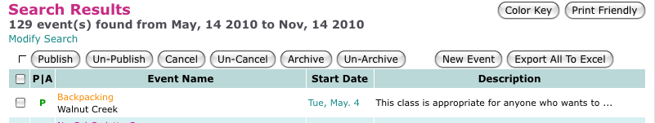
- After logging in, click on “Master Calendar” at the top of your screen.
- Click the “New Event” button (top right)
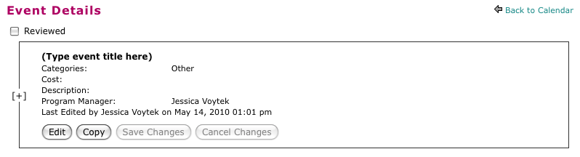
- Click on “Edit” in the Event box.
- Fill in the information in the fields provided. See below for descriptions of each field.
- Check your work!
- Click on “Save Changes”
- Modify the Sessions for this event (see below)
- Publish the Sessions (see below)

Field | Description
Title | Title of the event. This title will be shared across all sessions for this event.
Account Code | Account code for export to DoubleKnot. The account code is not required, by the system but is required by the Program Department. Adding any numbers to the account code text boxes requires the number to be 16 digits.
Event Page URL | The url of a page to use instead of the regular Master Calendar pop-up. This is most often used for featured events that have their own web pages. DO NOT USE this field for the registration URL unless you want to skip the Master Calendar pop-up all together. If you use an event page URL, please type a description as well so that the description preview will show in calendar view.
Category | Choose the correct category for your event. For some categories, you may have sub category options.
Cost | You have 4 cost fields. The first entry in each row should be a number, the second a description. For example:  $ 5 per girl l  $ 3 per adultl  You can use “Auto-text” to populate the description for each cost.
Description | Description of the event. This text area can be controlled using the CMS (see CMS below)
Please Note | Use this field for information that should be highlighted in the event listing.
Registration info | How does an interested person register for this event? If the event uses online registration and you will supply a registration URL you can leave this field blank. You can also use “auto-text” to populate this field.
Badge/Patch | Use this field to describe badges or patches that participants receive. You can also use “auto-text” to populate this field.
Volunteers | Use this field to describe the types of volunteers required for this event.
Program Aides | Check this box to add a note that program aides are needed for this event. If this event is to train program aides, please choose the “Program Aide Training” check box in the “Category” section of the Event.
Keywords | Include relevant terms that people might use to search for this event and that are not included in the title or the description of the event. Separate words and phrases with a comma.  For example: an event called “Equestrian Elites” that never uses the word “horses” in the description, might want to put the word “Horses” in the keyword text box.
Contact | Who should an interested person contact for more information about this event? In the absence of specific contact information in this box, the program manager’s contact information will be used.
Program Manager | By default this is the person entering information about the event. You can choose a different person as the program manager. The program manager’s name and contact information are not listed online unless no other contact information is supplied in the Contact box.

To Modify the Sessions for an Event
Please Note: New events contain one session by default. The start is the day the session was created. The session is un-published by default.
- Login
- Search for the event and click on its title
- Scroll down to the “Sessions for ‘______’” section and find the session you’d like to modify.
- If you’re creating a new session, click on “Copy Session” on the session that most closely matches the session you’d like to create. Copied sessions are un-published by default.
- Click on “Edit Session”
- Enter the appropriate information in each field. See below for a description of each field.
- To create a new meeting, click on the “+” button next to the last meeting in the list. This will copy the current meeting.
- Click on “Save Changes”
- Publish the session (see below)

Meeting(s)
Start |  | The start date and time for this meeting.
End |  | The end date and time for this meeting.
Daily checkbox |  | Check this box for meetings over multiple days that meet daily, rather than continuously overnight.
Location |  | Location of the event in plain text (as opposed to the next item, city drop down). Please do not list the location of troop meetings or other small private events.
City |  | The city drop down is used for zip code search only. It is not shown on the website or in the export files used for Double Knot or the Choices catalog.  Choose a city (from our service area) from the drop down menu. The city should be where the event will take place, or for out-of-town events with in-town transportation, the city where the girl will be dropped off. For events with no transportation that are outside of our service area, do not choose a city.  Choosing a city is very important for the zip code search, it gives the event a “geo-codeable” location.  Cities cut into multiple neighborhoods, like “San Jose (Almaden Valley)” and “San Jose (Downtown),” etc. are geo-coded to the same location. It does not matter which “San Jose” you choose for the zip code search, just choose one.  You can also narrow the city search drop down list by choosing a county first.
Attachment |  | This field is optional. Select a flyer from the drop down list, or see below for expanded instructions for adding a new document to the list.
Open To
Grades | Check-off the grades of girls invited to this session. If no girls are invited, don’t check-off any grades. The “Open to” text will automatically update with the grade information. You can modify the “Open to” text manually by clicking on “[edit].” Choosing the correct grade levels for your event is important for the search.
Other Participants | (optional) Choose the other participants who are invited to the event. The “Open to” text will automatically update with the “Other Participant” information. You can modify the “Open to” text manually by clicking on “[edit].”
Registration URL | Type the URL for the registration page here. As of August 2009, this is probably a DoubleKnot URL. Can be any URL if there is online registration through a different system.
When to Reg. | The dates that registration for this event start and stop. The session will show on the public calendar before and after these dates, but the registration information will only show between these dates. If you do not add any dates here, the registration information will show on the public calendar until the start date of the session.
Capacity | This information is required for use with DoubleKnot.

To Change the status of a session (Publish/Cancel/Archive)
- Login
- Search for the session or sessions you’d like to change.

To change a single session:
- Click on the title of the session
- Scroll down to the “Sessions for ‘________’” section
- Find the session you’d like to modify
- Click on the link for the action you’d like to take: Archive/Un-Archive, Cancel/Un-Cancel, Publish/Un-Publish

To change multiple sessions at once:
- Check off the sessions you would like to modify
- Click on the appropriate button to change the status of each of the checked-off events: Publish/Un-Publish, Cancel/Un-Cancel, Archive, Un-Archive
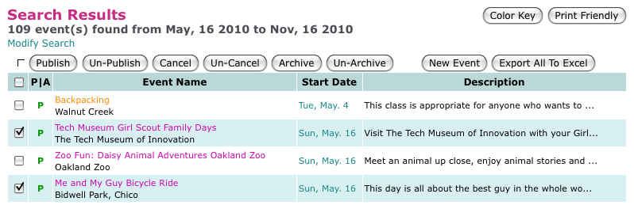

To Review an Event
- Login
- Search for the event you’d like to review
- Click on the title of the event
- Review the event
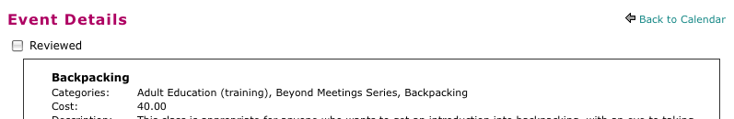
- Click on the “Reviewed” checkbox

To Copy an Event or Session
- Login
- Search for the event you’d like to copy
- Click on the title of the event
- Click on “Copy” in the Event section or “Copy Session” in the session section. Copied events and sessions are un-published by default.
- Modify, Save and publish the new event or session

To Use the Data-Entry Time Savers
The system is equipped with two data-entry time-savers. The “Save & Copy Event” and “Save & Create New Event” buttons at the bottom of the Event modify screen allow you to save the event you’ve been working on and copy it, or to save the event you’ve been working on a create a new blank event, all in one click.

To Export a List to Excel
Currently, this list is optimized for use with DoubleKnot.

- Login
- Search for the list of events you’d like to export
- Click on “Export All to Excel”

To attach a document or flyer to an event:
Please be sure to read through any documents you upload for prohibited content (last names etc.) and correctness. Also make sure the file name contains only letters, numbers, underscores “_” and dashes “-“. Change the file name if it contains anything other than letters, numbers, underscores, and dashes (the file’s extension, .doc or .pdf are exceptions).

- Fill in all other fields first, then click on “Save Event” to save your work thus far.
- On the line labeled “Attachment” choose the flyer from the drop down list. If the file you want to attach is not already listed in the drop down list…
- Click on “Documents” at the top of your screen and search for the document. It’s important to keep only one copy of a document on our website, so make sure you find out if the document you want to attach is already on our website. If the document does not exist yet, skip to step 8
- If the document does exist, click on “edit”
- Choose “Event Attachment” from the “Access” drop down menu
- Click on “Update Document”, and skip to step 12.
- Click on “Documents” and then click on “New Document”
- Fill in the information about that document in the fields provided (see below for description). Be sure to select “Event Attachment” for the access.
- Next to the label “Document” click on “Choose File” and browse your hard drive for the document you’d like to attach.
- Check your work!
- Click on “Update Document”
- Click on “Master Calendar” in the menu at the top to navigate back to the Calendar.
- Search for the event you’d like to attach this flyer to and click on the title of the event.
- Scroll down to the “Sessions for ‘_____’” section and find the session you’d like to attach the flyer to.
- Click on “Edit Session”
- Choose the flyer you’ve just uploaded from the drop down menu next to the label “Attachment”
- Check your work!
- Click on “Save Session”

Field | Description
Title | The title of the document. Write this out in whole words, and try to include a reference to the event and a date or year. For Example: “2006 Discoveree Flyer”
Document type | Choose a document type, probably “flyer”
Category | Choose the category that best describes the document you’re uploading, probably “event”
Access | Choose “Event Attachment”
Posted date | Leave as is.
Description | Write a short description of this document.
Keywords | Include relevant terms that people might use to search for this event. Separate words and phrases with a comma.
Document | See instructions above.

