**\*SAMPLE EMAIL FOR VOLUNTEERS TO SHARE WITH OTHER VOLUNTEERS-USE BEFORE NOV. 1**

**[Subject line: Who Wants a $50 Girl Scout Shop Coupon?]**

**Hello fellow Girl Scout volunteer [or personalize with their name]!**

Girl Scouts of the USA is running an awesome promotion in November where you can earn up **to two $50 online shop coupons (that’s $100 total!)** for recruiting new K-5 troop leaders for Girl Scouts of Greater Los Angeles! **PLUS**, the new leaders you recruit will receive a free volunteer resource pack!

**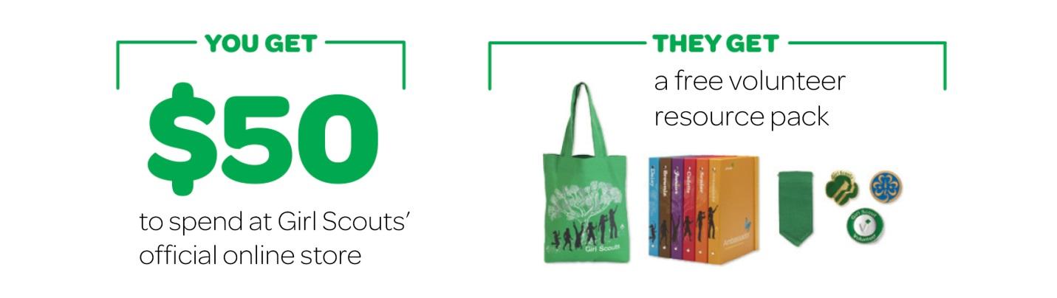  
  
Here’s how it works, in 3 EASY steps:**

1. Invite a friend to start a new Girl Scout Daisy, Brownie, or Junior troop.
2. Tell us you recruited a new leader at girlscouts.org/inviteafriend between Nov. 1­–Dec.1.
3. Once your recruit is verified as a new leader, GSUSA will email you a $50 coupon code to use on Girl Scouts’ online shop. The new leader will receive a free volunteer resource pack, delivered straight to their home!

The maximum number of $50 coupons you can earn is two ($100 max), but you can recruit as many volunteers as you wish to help grow our council and introduce new girls and volunteers to Girl Scouts!

**Pretty great, right?** Everyone wins, but most importantly, more girls will now be able to discover fun, friendship, and leadership through Girl Scouting!

Look for an email from GSGLA on Nov. 1 with more details and keep checking our website for invite-a-friend updates at [www.girlscoutsla.org](http://www.girlscoutsla.org). Happy recruiting!

Best,  
Your Name