Girl Scouts Greater Los Angeles Web Site

Web Site Admin Instructions

Navigation Instructions

Introduction:
The Girl Scouts Greater Los Angeles web site allows certain staff members to update information that is viewable by the general public on our web site, such as calendar events, documents, staff contact information, and on some pages web site content.

Navigation Items Vs Pages
Pages are HTML files on the site, navigation items are links to them. When you create a new page using this system a new navigation item is also created, however you can create and modify navigation items without creating new pages.

In This Document
To Login
To Create a Navigation Item
To Modify a Navigation Item
To Reorder Navigation Items
To Delete a Navigation Item
To Create a New Page
To Delete a Page (see CMS Instructions)

Step-By-Step Instructions:


To Login:
- Go to: http://www.girlscoutsla.org
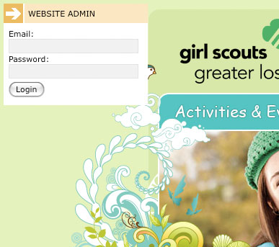
- Navigate to the page you would like to edit using the regular web site drop down menus
- Hover your mouse over the top left hand corner of the browser window. A gray bar should appear
- Click on the gray bar. A login box should appear.
- Type in your council email address
- Type in your password (this will be assigned to you or you can get a password reminder email by visiting www.girlscoutsla.org/admin and clicking on “Forgot your password? Click here…”)
Passwords are case sensitive.
- Click on “Login”
- When you are logged in you should see the “Web site Admin” control panel in the top right-hand corner of the screen. The control panel will “stick” to the top right-hand corner without regard to how you scroll or manipulate the browser window.

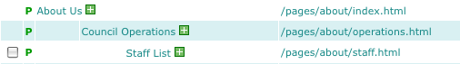
To Create a New Navigation Item
- Login
- Click on “Navigation”
- Click on the [+] next to the navigation item that will be the parent of the navigation item you want to create. For example, if this item will be a new item in the “About Us” menu, click on the [+] next to “About Us”
- Choose “Add Navigation Item” from the drop down menu
- Type the words you’d like to see in the navigation drop down next to “Nav Display Name”
- Click on “edit” next to URL
- Type the URL of the page you’d like to link to. This can be a link to a page on our site starting from “/pages/…” or a link to an outside page starting from http://
- Click on “edit” next to code name. Choose a name that is unique to this navigation item. This name will be used as the unique ID for this navigation item’s children. Once a navigation item has children it is not a good idea to change the code name. Code names should include only letters, numbers and underscores, no spaces or special characters. Characters that are not allowed will be changed automatically.
- If the page that this item links to is ready for public viewing, click on the check box next to “Publish Link”
- Click on “Update Navigation Item”

To Modify Navigation Item
- Login
- Click on “Navigation”
- Click on the title of the navigation item you’d like to modify
- Change the settings for this navigation item
Note: it is not a good idea to change the “Code Name” of a navigation item with children. Be sure to choose a unique code name for each navigation item.
Note: changing the URL of a page does not move the page.
- Click on “Update Navigation Item”

To Reorder Navigation Items
- Login
- Click on “Navigation”
- Click on the “Reorder children” button
Note: you can only reorder children when there is more than one child. The re-order children button does not appear next to navigation items with 0 or 1 children.
- Type numbers into the fields provided, lower numbers will appear higher in the list. When two or more navigation items share the same order number, navigation items will be sorted alphabetically for that number.
- Click on “Reorder Items”

To Delete a Navigation Item
Note, this WILL NOT delete the page, just the link to the page in the navigation. To delete a page, see “Content Management Instructions” instructions.

- Login
- Click on “Navigation”
- Click on the check box next to the item you’d like to delete
- Click on “Delete Nav Item”
- Click on “Ok”

To Create a New Page
- Login
- Click on “Navigation”
- Click on the [+] next to the navigation item that will be the parent of the page you want to create. For example, if this page will be a new page in the “About Us” section, click on the [+] next to “About Us”
- Choose “Create New Page” from the drop down menu
- Type the name you’d like to use for the file name. This should only include letters, numbers and underscores or dashes, no spaces or special characters. Spaces and special characters will be removed automatically.
- Type the title of the new page
- Choose the top level section to be used for “In This Section”
- Click on “Create Page”
- To start editing the page, click on the link to the page next to URL
See “Content Management Instructions” for information about editing the new page.

