How to Renew a Membership

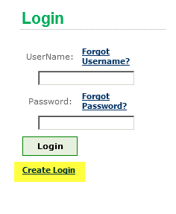
- Go to www.girlscoutsla.org and click on the eBiz tab to get to the login page.
- After logging into your account please be sure to click on the My Account area on the main menu.
- Next, click on the, renew for 1 year button in the Membership Info box. (New members will see a join now button).
- The next page will display the membership renewal. A red *ADD* button will appear requiring the member to update personal information.
- Please update all required fields on each screen to proceed.
  - Adults should update their position/role in the troop for the next year. Please type in the 5 digit troop number or the three digit service unit number and select the desired position. If the position is not known please skip this area.
  - When searching for schools or employers please type in partial names to pull up a list to choose from. If not found please use unlisted.
  - Don’t forget to donate to our Family Partnership Campaign! *A link to donate will also be sent via email on the membership confirmation.
- When all information has been updated and saved, please proceed to checkout. The red *ADD* button will now show as a green *EDIT* button indicating all required fields have been entered.
- Next, type in credit card information and click the submit button. When the order has been processed an Order Summary page will appear. An email confirmation will also be sent directly to the newly registered member within 30 min of the purchase.
- Congratulations! Your membership is now complete. Please verify your troop number on the membership confirmation. If anything is incorrect please email the GSGLA Help Desk at helpdesk@girlscoutsla.org.

