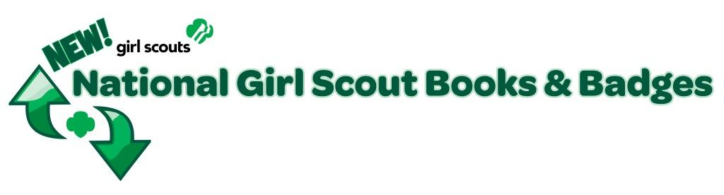

QUESTIONS & ANSWERS: NEW NATIONAL GIRL SCOUT PROGRAM OF
BOOKS & BADGES: Updated June 23, 2011

Q. I’ve heard that GSUSA is introducing new merchandise and phasing out existing Girl Scout program handbooks and badge books. Why?
A. Girl Scouts is celebrating its 100th Anniversary in 2012, and what better time to refresh the look of program handbooks and badges to make them more current, fun, exciting and engaging for girls and leaders. In response to feedback from Girl Scouts nationwide, the new program offers variety, choice and relevance!

Q. When will the changes happen?
A. This program transition will begin September 2011 through June 2012. GSUSA is making available the contemporary and colorful Girl’s Guide to Girl Scouting in September 2011 and updated, fun badge and award activities in spring 2012, along with a revised handbook section.

Q. Which Girl Scout levels will be affected?
A. All badges and program books at all levels for girls and leaders are being retired except for the Journey books and their earned awards. Each grade level (Daisies to Ambassadors) will be able to enjoy a newly designed Girl’s Guide to Girl Scouting in September of 2011.

Q. How will the Girl’s Guide change? [add image]
A. Reinforcing variety, choice and relevance, the new Girl’s Guide to Girl Scouting will offer six unique and colorful binder designs (one for each GS level) featuring:
- Handbook Section
- My Girl Scouts Section
- Legacy Badges
- Cookie Business Badges
- Financial Literacy Badges
- Skills-Building Badge Sets for Brownies, Juniors, Cadettes and Seniors will be available; 3 per age level tied to 3 Journey topics

Q. Are badges going away?
A. No, earning awards is an integral part of Girl Scouting, as it has been for nearly a century. Badge activities complement the Journeys and contribute to the first leadership key: Discover. Some badge topic areas are out of date and are being permanently retired, while some totally new badges will be introduced. Other offerings will combine current topics and favorite activities into badges that will feel very familiar to all of us. All badges will have great energy and a bright new look. New badges will be released in The Girl's Guide to Girl Scouting.

Q. How will badges change?
A. The new badges will combine contemporary topics of interest to girls and long-time favorite activities. Reinforcing activities with a purpose and keys to leadership, the newly designed, colorful, iron-on badges will be categorized as:
- Legacy: Artist, The Girl Scout Way, Citizen, Cook, First Aid, Athlete, Naturalist
- Financial Literacy: Girls can earn a different one every year; Daisies earn Financial Literacy “Leaves.”
- Cookie Business: Girls earn a different one every year; Daisies earn Cookie Business “Leaves.”
- Skill Building: Whether girls choose “It’s Your World, It’s Your Planet or It’s Your Story” Journeys, they can choose corresponding badge sets to add to their Girl’s Guide, with dedicated badge topics
- Make Your Own: Girls use their imagination!

All earned Try-Its, Jr. Badges and Interest Project Awards (IPA’s) will all be called “badges” in the new program. All newly designed badges will be available in the spring of 2012 through our Service Center Shops or by ordering online, through our GSGLA website.

Q. How are Daisies badges and activities affected?
A. Daisies will enjoy earning Petals with robust activities, and they earn Financial Literacy and Cookie Business Leaves.

Q. Will girls still earn Cookie badges?
A. Yes. There will be two sets of skill-building badges related to the Girl Scout Cookie Program. A girl will still be able to earn the Girl Scout Cookie Activity pin when she participates in the Cookie program.

Q. What awards are new?
A. My Promise, My Faith and Journey Summit pins are exciting award additions!

Q. What will happen with existing bronze, silver and gold awards?
A. Bronze, Silver and Gold awards will remain and are not changing or being retired with the new Girl’s Guide.

Q. What has been updated?
A. Safety Awards; CIT, VIT and P.A.; and Troop Crests.

Q. If my troop is in its last year at a certain level and they have the existing Try-Its, Jr. badges and IPA’s they still want to earn, can they find them in the Service Center Shops to complete their current program?
A. Effective June 23, 2011 and moving forward, you will need to place orders for existing badges and pins online, at www.girlscoutsLA.org. Because all the existing badge’s inventories have been reduced in our shops as we transition to the new Girl’s Guide to Girl Scouting program, we may have to special order your badge needs.

Q. Will adult guides to The Girl's Guide to Girl Scouting be produced?
A. Adult guides will not be necessary as volunteers will be able to apply what they've learned from their journey adult guides, Volunteer Essentials and Safety Activity Checkpoints.

Q. What is GSGLA’s timeframe for introducing the new program guides and badges?
A. Six colorful binders uniquely created for each level of the Girl’s Guide to Girl Scouting will be available in September 2011 and new, exciting badges will be in the spring of 2012 for purchase through our Service Center shops or our GSGLA online shop. We will update you as soon as possible on a more definitive timeframe as to when the badges will be available from GSUSA.

Q. How, and for how long, can we order remaining inventory?
A. We have depleted inventory levels in our Service Center shops. To make sure that we help you complete your existing program badge needs, and so that we can fulfill your end-of-year orders, we highly encourage you to order existing badges and pins online. Beginning June 23, 2011, existing badges and pins will only be available online, at GSGLA's Online Store . Typically, orders will be filled within two weeks if the merchandise is available, as we may need to special order your badges through our existing vendor or through another Council. Unfortunately, we can’t guarantee that all merchandise will be available as time progresses but we will do the best we can to fulfill orders.

Please rest assured that we will update you as often as possible about badge availability as we receive communications from GSUSA. Knowing that timelines may shift due to circumstances beyond our control, we appreciate your flexibility.

For merchandise transition lists, dates and tips, please visit www.girlscoutsLA.org.

