

2012 Cookie Program

CREDIT CARD READER INSTRUCTIONS

Below are the steps a troop needs to take regarding the credit card reader. It is recommended that troops complete these steps by February 15.

- Confirm your “smart phone” is on the list of supported phones – visit http://devices.roamdata.com/device-center/index2.php

- Because Sage (our service provider) has learned that some mobile credit card deposits and fee debits have rejected due to filters that may be on your bank accounts, in order to prevent potential delays in receiving funds, you should provide Sage Payment Solutions’ originator ACH id numbers to your bank to authorize SPS EFTs.

Here are the originator id numbers:

1246825337 Sage Payment Solutions - HQ COMPANY ID
4040201020 SPS/ Rejects - Imperial Bank CCD Written
4040301020 SPS/ Rejects – EFT Cash CCD Written
4041101020 SPS/Cancellation Fees CCD Written
4044201020 SPS/Supplies CCD Written
1541507947 EFT Fees

- Download the 2012 Mobile Credit Card Agreement form from the Council website
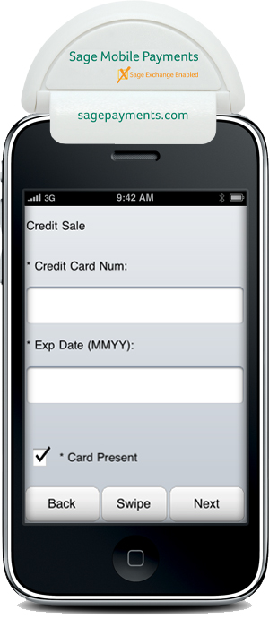
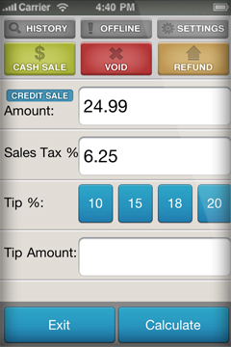
  - see Cookies & Nuts > Cookie Central Homepage and scroll down and click on Forms
  - email or bring to your Council Service Center

- Picking up your credit card reader:
  - Come to your Council Service Center (max 2 per troop)
    - If you did not pre-send your 2012 Mobile Credit Card Agreement, bring it with you
    - The 2012 Mobile Credit Card Agreement also available at the council office
  - IF your Service Unit Cookie Chair opts to pick up readers for all troops in the Service Unit, be sure to provide her with your signed 2012 Mobile Credit Card Agreement.
    - Complete a form for each person receiving a reader (including banking info on only one)

- By February 20, you should receive a mobile welcome email from Sage that includes a link
  - click or copy/paste URL into internet browser.
  - Register the smart device and user info, click send.
    - When you are prompted for last 4 digits of social security or tax id, input 9999 OR 1111
  - within 5 minutes, user will receive another email confirmation with the username and password created during the registration process
  - Download Sage Payments app (free) from ITunes app, the Android Marketplace or Blackberry Appworld
    - Use version 2.0 of the app (iPhone/Android/Blackberry)
  - Click/select the Sage Payments app icon on the smart device
    - enter user id/password for Sage Payments
    - plug in swipe device to audio jack
      - be sure the audio volume is set to max
      - confirm the phone is not on mute

- Begin taking credit card payments at your boothing sites in March (see step e. in item 5 above)
  - You can use the reader to accept credit card payments when delivering pre-ordered product to your customers
  - See the Detailed Instructions on Using Mobile Credit Card Reader at the Council website in Cookies & Nuts > Cookie Central Homepage and at the Council section of the Cookie eVIP Training site

- Online Management Portal -- http://www.mysagemobile.com – (same password as for app)
  - See a summary of all your transactions and track your account activity
  - Have additional adults who might be using the reader? Add them to your account at the Online Management Portal
    - Each user will need to download the app to their smart phone

- Credit card readers are due back to the council service center at the end of the sale, no later than April 6.
  - Card readers returned late may be subject to a $75 fee
  - Card readers not returned at all WILL be subject to a $75 fee

Call your Product Sales Manager if you have questions.



