 | Contact: | Name, Volunteer Title  Service Unit  Phone Number  Email Address
PRESS RELEASE

FOR IMMEDIATE RELEASE
HEADLINE HERE, MAKE IT CATCHY
This line summarizes the essence of your press release

CITY, date – This is your leading paragraph. It should grab the reader’s attention with a hook. Then quickly give the who, what, where, when.
You can fully develop the “why” message of your release in a few body paragraphs. Include the basics (who, what, where, when), but also include the most interesting facts about your event/happening.
Your most important information should be higher up in your press release. Start with the must-know info and end with the would-be-nice-to-know info. Toward the end, insert a quote from a service unit manager, troop leader, or—better yet—a girl. Keep everything on one page.
Remember: Your readers (reporters and editors) often do not know Girl Scout lingo. They do not know what a service unit is, for example, so instead of using Holly Hills Service Unit, use Girl Scouts in Beverly Hills, etc.
Always end with a recruitment message or a statement regarding where someone can go for more information. It’s recommended to simply say: For more information about this event, visit [insert website name.] To join or volunteer for Girl Scouts, visit girlscoutsla.org.
About Girl Scouts of Greater Los Angeles
Girl Scouts of Greater Los Angeles serves more than 40,000 girls in partnership with more than 20,000 volunteers throughout the diverse communities of Los Angeles County and parts of Kern, San Bernardino, and Ventura counties. The council engages girls through programs in Leadership, Business and Financial Literacy, Outdoor Adventure, STE[A]M (science, technology, engineering, art, math), and Healthy Living. To join, volunteer, reconnect, or support, visit www.girlscoutsla.org or call 213-213-0123.
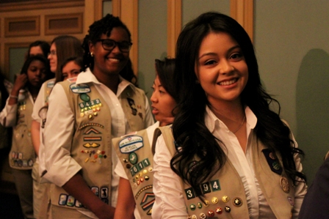
PHOTO CAPTION: It’s recommended to include a photo and caption along with your release. You can paste it here and include your caption, but also attach it to your email as a separate .jpg file. If submitting to a print publication, make sure your picture attachment is a high-resolution image (at least 300 DPI).

