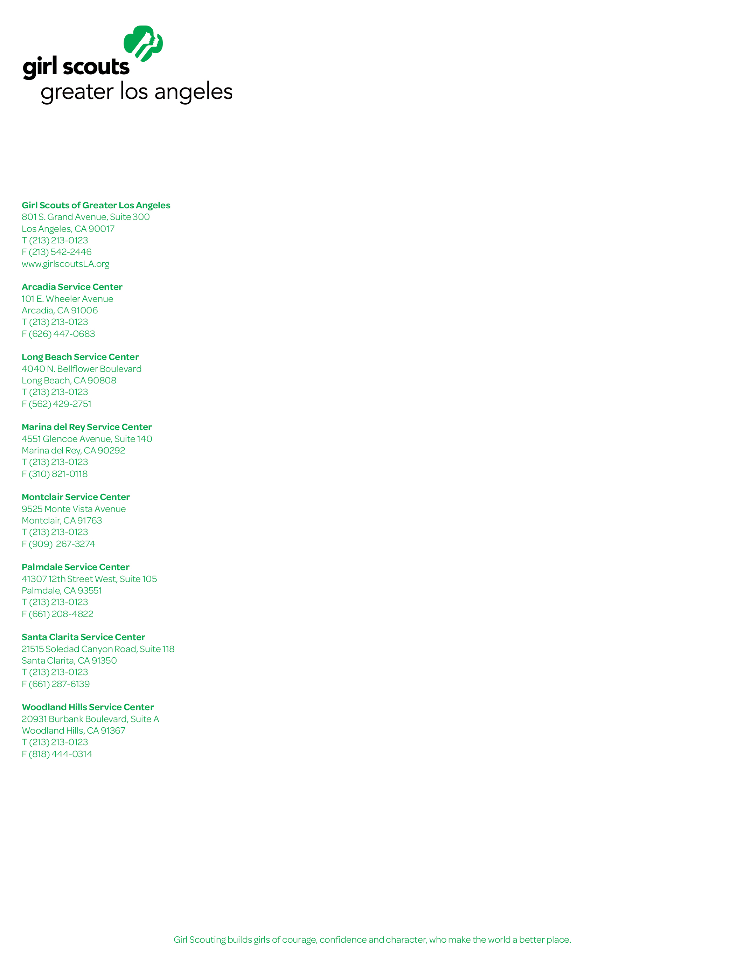
Date

Name
Business
Street
City, State, Zip

Dear Store Manager

Name
Service Unit Name Boothing Chair
Street
City, CA, Zip
Phone
Email
The 2016 Girl Scouts of Greater Los Angeles Cookie Program will begin on January 24, 2016. In addition to being a great opportunity for girls to earn money for the Girl Scout year, the GSGLA Cookie Program is an important learning opportunity. Participating girls will set and achieve goals, improve their business skills, and learn about reaching their potential.

We would like to ask you to join with Girl Scouts of Greater Los Angeles to support the girls in your local community by allowing them to set up a booth sale in front of your business February 5 – March 6, 2016. With adult supervision, girls set up a table to sell a variety of Girl Scout Cookies and will be respectful and courteous at all times. Troops are scheduled in shifts daily, 10am – 8 pm (store/location hours permitting) and girls will be identified as Girl Scouts by wearing their pins and/or uniform.

We are hoping we can count on your valued support for the 2016 Cookie Program. It is with the continued support of businesses like yours that directly contribute to the success of the GSGLA Product Sale Programs.

Regardless of your response, please take a moment to complete the enclosed Booth Site Permission form. On behalf of Girl Scouts of Greater Los Angeles, I thank you for helping us build girls of courage, confidence and character, who make the world a better place!

Sincerely,

