



**Service Unit User Manual**

**August 3, 2015**

**https://eBudde.littlebrownie.com**

# Table of Contents

Table of Contents 2

What’s New 3

Computer Specifications Information 3

Navigating the System 5

System Access 6

Login Information 7

New Security Requirements 7

Contact Information Page 8

Forgotten Password 9

Menu Bar 11

Navigation Tree 12

Service Unit Tabs 13

Dashboard 14

Contacts Tab 17

Settings Tab 21

Edit Settings 21

Left-click the Update button to save the changes. Left-click the Cancel button to leave the page without saving the changes. 24

Edit Messages 25

Edit Calendar Events 25

Troops Tab 26

Adding or Editing a Troop 27

Special Troop Contacts 28

Deleting the Troop 31

Un-submitting Troop Orders 32

Init. Order 33

Initial Order Page- Troops placing orders 33

Delivery Tab 34

Transaction Tab 34

Deposits Tab 34

Navigating the Deposit Information Page 35

Rewards Tab 36

Booth Sites Tab 37

Reports 38

Appendix – Troop Sales Report 44

# What’s New

1. eBudde™ has a new look! All screens and forms refreshed.
2. New Help Center
3. Gluten Free Pilot – Import initial order troop/service unit orders
4. Gluten Free Pilot – Mark inventory unavailable for pending orders.
5. Pending orders allowed for dates/times when cupboard is open
6. Sort by pick up date on transaction tab
7. Troops can always print receipt of pending order
8. Print service unit number on receipt and export
9. Pickup date and time prints on email to cupboard clerk
10. Cupboard weekly report filter for troop/service unit transactions only
11. eMail sent to troop/su when order is un-pended
12. When sending emails, allow selection of specific areas, service units and/or troops on all levels
13. Allow some formatting on email messages.
14. Allow maximum reward items per troop for participation and volunteer types
15. Move to the Cloud – Amazon Web Services
16. Past booth dates fall off current sign-up report
17. Add day of the week to current sign-up report
18. Notes based on individual location, not on business as a whole
19. Troop Variety Summary Report on Area and Service Unit Levels
20. Booth Sale Recorder report on the Service Unit level

# Computer Specifications Information

The eBudde™ system has been tested on a variety of computer types and different web browsers.

**Approved web browsers:**

IBM Compatible – Microsoft Internet Explorer version 9.x and higher, Firefox 36.0 and higher, Chrome 38.x and higher.

Macintosh – Safari 7.1.x and higher, and Firefox 36.x and higher, Chrome 38.x.

**Approved computer specifications:**

Recommended Minimums:

2.0 GHz CPU - 2GB RAM

Recommended Systems:

2.5 GHz CPU - 3GB RAM

The eBudde™ system uses Microsoft Excel .xlsx for the printing of the reports. If you have users that do not have the Microsoft Excel program, a report viewer for IBM compatible systems can be downloaded from the following web address:

<http://www.microsoft.com/download/en/details.aspx?displaylang=en&id=10>

The eBudde™ system can also print in Adobe PDF format. To download Adobe Acrobat, use the following web address: http://get.adobe.com/reader/

eBudde™ has scheduled time-outs at 1 hour of inactivity. eBudde™ will close out your session, logging you out if you have been inactive in the system for 1 hour.

Effective January 1st, 2015, eBudde™ will be updated to work on Apple iPads and Microsoft Surface devices.



# Navigating the System

**Add More** - The “add more” button allows you to enter in additional rows on transaction tab product transaction form. You can activate this button by pressing the spacebar or clicking on it.

**Enter Key** – The enter key is used to complete a row on a page. It can also be used to complete a page when the page has only one button available on the page.

**OK** – The “OK” button completes a row on a page. This button tells eBudde™ you are done with the data entry on the row.

**Tabs** – The tabs available on the page allow you to add, change, delete or view information. These tabs are specific to the user access level. Council users see the council tabs, areas see the area tabs, service units see the service unit tabs, and troops see the troop tabs. Below is an example of the tabs. To select a tab, click anywhere on the tab.



**Tab Key** – The tab key is used to move from one box of information to another on all screens.

# System Access

Every season, current users will be reset to a council default password. Your council will notify you of this password.

If you are a brand new user to eBudde™, you will be notified by your council or by email of your password. If you are notified by an eBudde™ email, the following information will be in the email:

* Web Address - <https://eBudde.littlebrownie.com>
* Email Address
* Temporary Password

We recommend you add <https://eBudde.littlebrownie.com> to your **Favorites** for easier access.

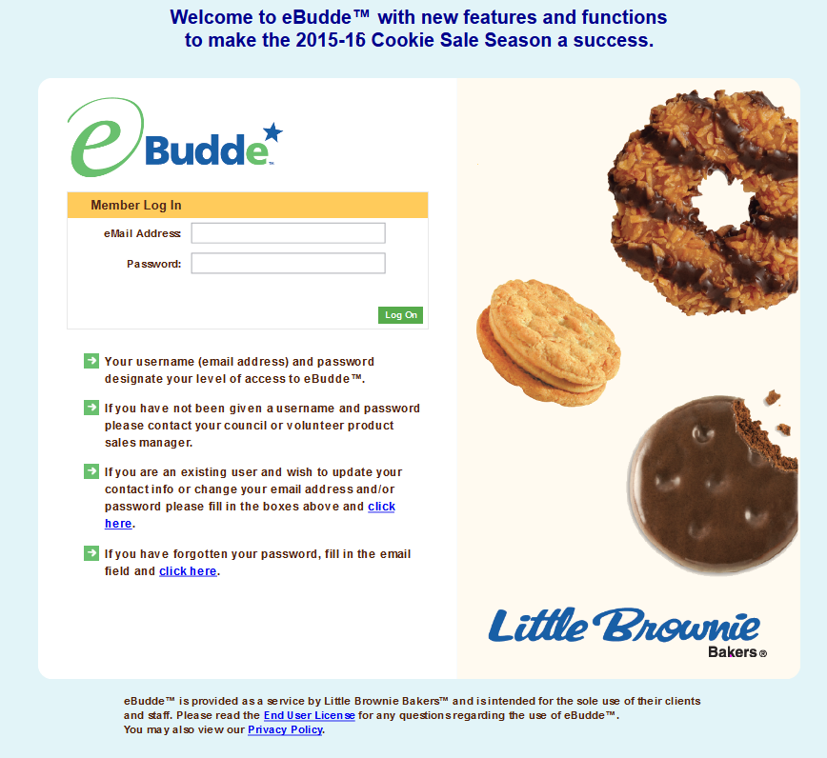

The login screen consists of four parts:

* Login information
* Updating contact information
* Forgotten password
* End User License and Privacy Policy

## Login Information

**NOTE: All eBudde™ users will be considered new users and have a new temporary password. Contact your council for further information.**

Users who have already logged in previously this season will enter in their email address and **personal** password. Click the **Login** button or press enter to complete your login information. The system will then access your council’s information.

New users will enter in their email address and **temporary** password sent to you in the email from the system or by your council. Click the **Log On** button or press enter to complete your login information. The system will then direct you to the **Contact Information Page**. Once you have completed the contact information page, you will be given access to the system.

## New Security Requirements

Temporary passwords only good for 24 hours.

The password requirements are as follows:

* Must be 8 characters long
* Must have at least one capital letter
* Must have at least one non-alphabetic character

There will be a strength meter to help create a strong password.

You will be required to answer four security questions.

Login attempt rules are as follows:

* Limit to five consecutive bad login attempts
* Account disabled for 10 minutes

Security questions:

* You can select your security questions from a drop down list
* You cannot use the same question more than once.

## Contact Information Page

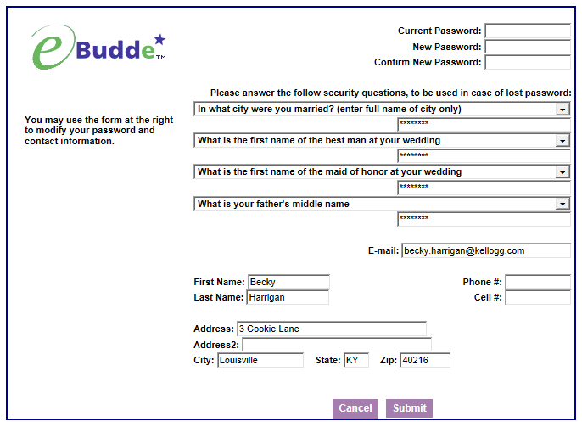

Current users – This form is available to make changes to your password, email address, security questions and personal information. To access this page click on the link provided on the login page.



New users – You will be required to fill out this form the first time you try to access the eBudde™ system. **You must change your password to something other than the temporary password.** All the information on this form is mandatory. Once you have entered in all the information, click the **Submit** button or press **Enter.** You will then enter the eBudde™ system.

## Forgotten Password

**A forgotten password does not require a phone call!**



Users can now reset their own passwords. Click the link **click here** under the fourth bullet point.

eBudde™ will offer you two ways to reset your password. You either can have a temporary password sent to you or you can answer your security questions to reset your password.

To get a temporary password emailed to you, click the **Submit** button next to option 1.

To use the security question option, click the **Get Questions** next to the email address. Enter in the CAPTCHA code; Answer the two security questions, enter in a password in the password box and re-enter the same password in the confirm password box. Click the **Submit** button. eBudde™ will tell you that you password is now changed. Click the **Back to Login Page** to login with this password.

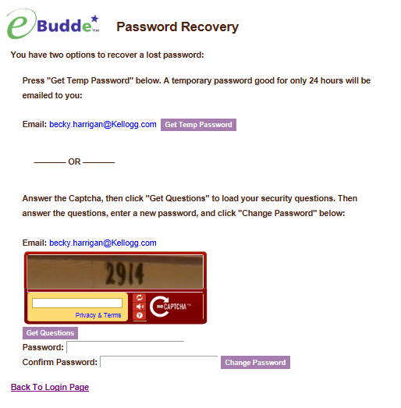

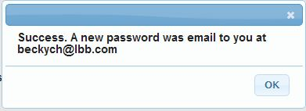

# Menu Bar



The Menu Bar provides additional support for you in eBudde™.

**Season drop down -** Allows you to see previous season’s data (if applicable)

**Quick Links** – This provides a list of additional links for easy access.

**LittleBrownie.com** – This provides a link for you to go to the Little Brownie website that has additional resources.

**VIP eTraining** – This provides a link to the VIP eTraining site that has cookie program and training resources.

**Cookie Club** – This provides a link for you to go to the Little Brownie Cookie Club website where your girls can track cookie sales, send eCard promises and maintain their contact list.

**Log Out** – This allows you to log out of the system.

# 

# Navigation Tree

Once you enter the system, you will notice that the screen is divided into two sections.

The navigation tree will start with your service unit name and number. As you create your troops this tree will expand to list all your troops.

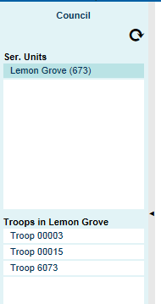



If you click this icon, you will refresh the tree. This is helpful if you are adding troops

# Service Unit Tabs

On the service unit level the following options are available using a tab method similar to file folders in a filing cabinet. To access a tab, click the tab name and the system will display the appropriate page.



**Dashboard –** The dashboard gives you an up-to-minute snapshot of your troop’s orders, goals, financials and per girl averages.

**Contacts** - The contacts tab is used to view the service unit level users name, personal information, email and passwords.

**Settings** – The settings tab will allow a service unit to specify how the data will be entered for the service unit and to add additional service unit level users.

**Troops** – The troops tab is for adding, changing, and/or deleting troops.

**Init. Order** – The Init. Order tab is to verify troop cookie initial orders and submitting the troop/service unit order to the council. This tab is also used for service units using the “Fast Order Entry” which allows create troop totaled orders.

**Delivery** – The delivery tab is used by service units to select their service unit delivery station (if applicable)

**Transactions** - This tab is to move cookies from the service unit to the troops (if applicable) The service unit then can see their inventory for cookies.

**Deposits –** *Council will record troop ACH debits here (as well as any NSFs, etc.)*

**Rewards** – The rewards tab is for service units to verify troop reward orders and submit order to the council.

**Booth Sites** – This tab will allow service units to approve troop booth site requests.

**Reports** – The reports tab is for service units to print reports for cookie orders, reward orders, deposits and inventory transactions.

**Help Center** – The new Help Center will provide you additional information on the eBudde system.

## Dashboard

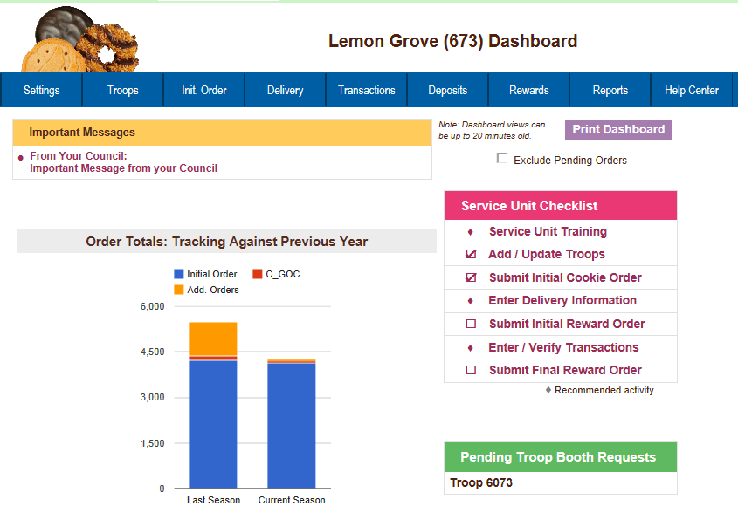When you enter the screen the system will display the navigation tree and the dashboard. The dashboard shows messages from your council staff or area manager (if applicable) It also will show you the current status of troop cookie orders, reward orders and financials. It will remind you of all the deadline dates for the current sale. These dates will include eBudde™ deadline dates and council-specific dates. There is a service unit checklist that will include eBudde™ items and council-specific items. eBudde™ will also let you know if there are any pending troop booth requests. There are also graphs on orders, goals and per girl averages. All of these graphs are printable using the **Print Dashboard** button.

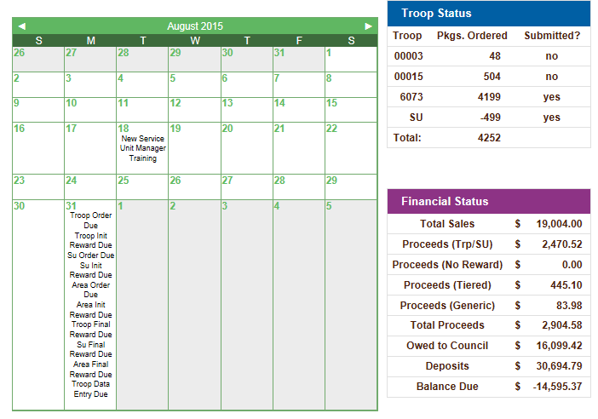

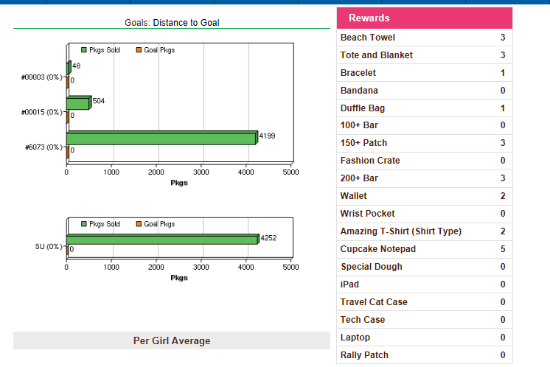

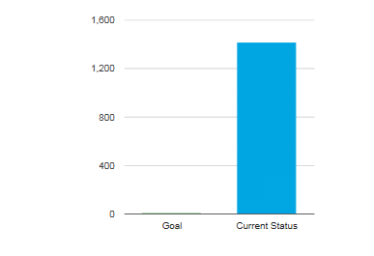**Messages** – Messages from your council will be displayed here. In addition, if your council has an area level, those messages will be displayed here as well.

**Service Unit Checklist** – the service unit checklist includes items to do in eBudde™ but also can include council-specific items

**Pending Troop Booth Requests –** Troops that have requested a local booth site will be listed here

**Troop Status –** This lists the troops in the service unit and how many packages they have ordered and if they have submitted their initial order. The package count gets updated throughout the cookie sale.

**Financial Status** – The financial totals for the service unit are listed here. The detail for this information can be found on the Troop Sales Summary report or the individual Troop Sales Report

**Rewards –** This will list the rewards currently ordered by the troop. The troop must submit the troop order for the numbers to be displayed on the dashboard

**Order Totals Graph** – Comparison graph for the service unit from last year to current date. The last season numbers can be found on the service unit settings tab. This season numbers come from the transaction tab for the service unit and the troops.

**Calendar** – The calendar will show eBudde™ deadline dates and council-specific dates.

**Distance to Goal** – Each troop will be displayed showing the goal that they set on the troop setting tab and the cookies that they have sold. In addition the service unit goal can be entered on the service unit setting tab and eBudde™ will calculate the packages sold by the troops to compare against the goal and is displayed on the dashboard.

**Per Girl Average** – This graph depicts the per girl selling average for the service unit which are the total boxes sold by troops on the initial order and service unit initial orders / girl selling from the troop setting tab. The goal number comes from the goals entered on the girl tab.

Contacts Tab

The information supplied on this screen was entered by you or set up by your council. To add or remove a contact you will need to select the **Settings** tab.

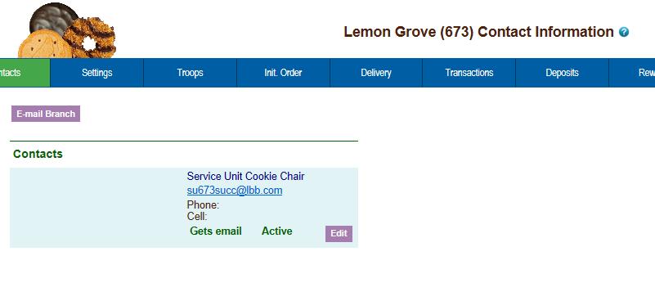

To email your troops, click the **email Branch** button. The system will display a screen with instructions and email limitations. Emails that you send through eBudde™ will be sent to you troop contact’s regular email box. There is no replying of email in eBudde™. You can send one or more attachments with your email as long as the total size does not exceed 5 MB.

To ensure that your recipients receive this email you may want to inform them to specify in their email system to allow the following email address as an allowable sender: do_not_reply@littlebrowniebakers.com

**NOTE: If you add attachments, eBudde™ will not send attachments via email. eBudde™ will upload your attachments and send a link to the attachments via email to your selection. The links will be active for 45 days from date sent.**

You can now designate if you want to email just those contacts labeled as **Primary** contacts you can check the box under Primary Only and eBudde™ will only email to those contacts. See page 19 on creating users as Primary contacts.

**You will need to enter the CAPTCHA code to send the email.**

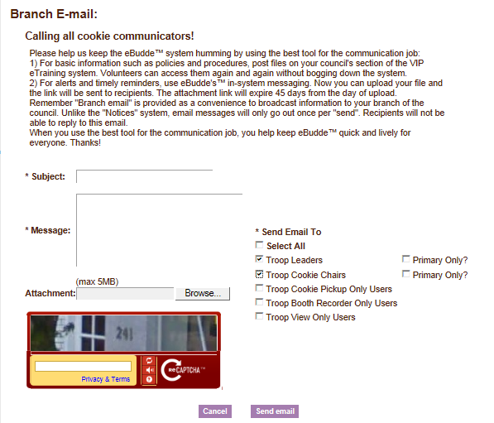

To edit your **Service Unit Contact** information click the **Edit** button below to the contact name.

The system will open up a page to change the information. To create a new contact, see the section on service unit settings.

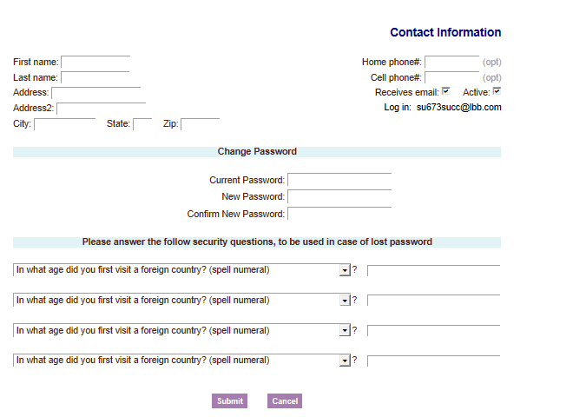

Change the information by clicking in the box and keying in the new information. Click the **Submit** button to save the changes. If you wish to cancel the information keyed, click the **Cancel** button.

You can change your password by entering your current password and new password and confirming that new password. You would then click **Submit.**

You can now change your security questions here as well. Enter the information by clicking in the box and key in the new information. Click the **Submit** button to save the changes. If you wish to cancel the information keyed, click the **Cancel** button.

You can update a user’s address and phone number information. Update the information and click the **Submit** button. If you do not want to make the changes, click the **Cancel** button.

If you have access to other’s contact information, you will not be able to update password information or security information but you can reset their password.

You can give them a temporary password that is good for only 24 hours. If the user does not log in within the 24 hour period, you will need to assign the user another temporary password.

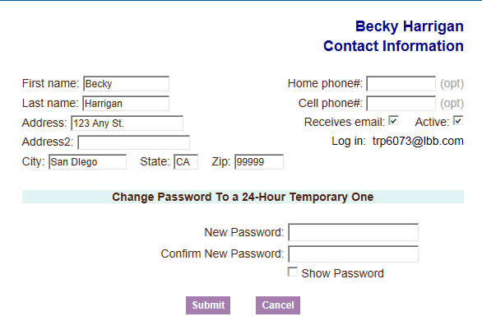

Enter the password in the new password box and then enter it again in the confirm new password box. Click the **Submit** button. eBudde™ will send the user an email with the temporary password information informing the user that the must log in within 24 hours.

If you do not want to create a temporary password, click the **Cancel** button.

## Settings Tab

The settings tab allows for adding new service unit level users, changing default service unit settings, creating eBudde™ messages for troops on the dashboard, entering last year’s data for the dashboard comparison graph.

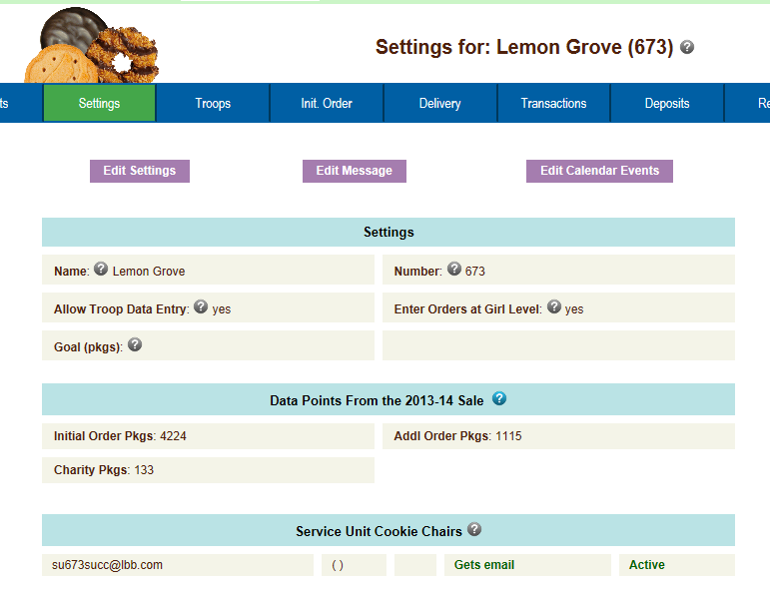

This information was set by your council but you can make some changes appropriate to your service unit. You may be allowed to change the settings for allowing troop data entry and girl entry level data entry and your previous year’s sales data. You can also add additional contacts for your service unit. In addition, you can create a message that troops will see when they log into eBudde™.

### Edit Settings

To update this information, left-click the **Edit Settings** button. The system will display the following screen:

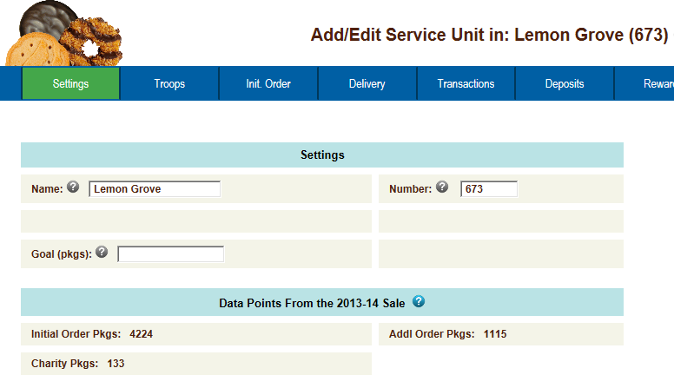

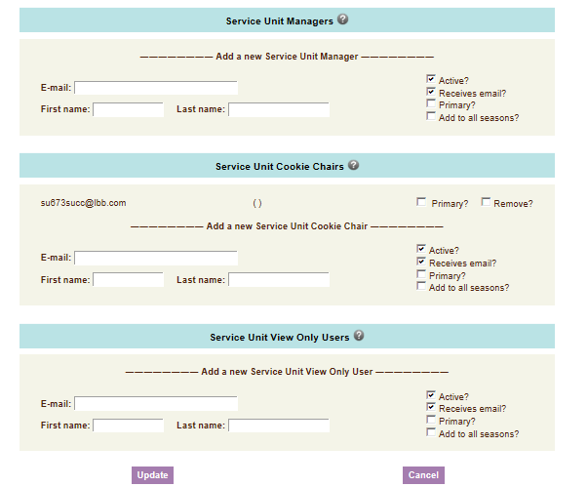

Council may allow service unit to view troop banking information. If so, the role for that access is Bank Account Managers. Only users designated as Primary have access to add users to this role.

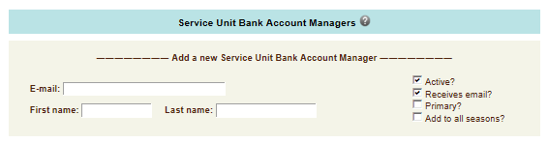

**Name of Service Unit** – The service unit name.

**Service Unit Number** – The service unit number.

**Allow Troop Data Entry** – check this box if the troop is going to enter their orders in cases with booth information. May be inaccessible per council customization.

**Enter Orders at Girl Level** – Check this box if you or the troop is going to enter the order by girls in packages. . May be inaccessible per council customization.

**Data Points from the Previous Year Sales – May be inaccessible per council customization**

**Initial Order Pkgs** – Enter in the number of packages that were ordered last year at initial order time by the service unit and/or troops.

**Addl Order Pkgs** – Enter in the number of packages that were picked up after the initial order was received by the service unit and/or troops.

**Charity Pkgs (optional)** – Enter in the number of packages last year that were sold as part of a council-sponsored Gift of Caring program.

**Service Unit Managers** – this can be used to add another service unit contact as a service unit manager. You can specify if the user will be receiving appropriate emails and if the user will be able to access the system.

**Service Unit Cookie Chairs** – this can be used to add another service unit contact as a cookie chair. You can specify if the user will be receiving appropriate emails and if the user will be able to access the system.

**Service Unit View Only Users** – this can be used to add another contact to the service unit that can only see the screens and print reports. This user cannot make any changes in the system.

**Service Unit Booth Site Approvers** – This can be used to add another contact to the service unit that can only use the booth site tab and report tab. They will be able to see troop level booth site tab as well. This user will be allowed to approve troop booth requests for a local booth site.

**Service Unit Booth Site Uploaders** – This service unit contact can only use the contact tab, booth site tab for uploading booth site information only and the report tab. They will be allowed to upload council site booth sales via spreadsheet. Will not be allowed to change or delete any booth sites in the system. This user will be allowed to print reports and change personal login information

**Service Unit Bank Account Managers** – this can be used to allow permission for a user to see troop bank account number and routing number in reports. You can have a user that has only this permission or add this permission to a user that has another service unit role.

**Remove?** – You can remove users by clicking the remove? Box next to the email and name. **NOTE: Do not remove yourself or you will not be able to get back into the system.**

**Email:**  – Enter the email address of a new troop contact under the appropriate header.

**Active** – If you enter a new troop contact, mark if you want this user to access the computer web-based software system. Uncheck the box if you do not want this user to access the computer web-based software system.

**First name**: (Optional) – You can enter in the contact’s first name. The contact person once they log in can enter it as well.

**Last name:** (Optional) – You can enter in the contact’s last name. The contact person once they log in can enter it as well.

**Receives email** – If you enter a new troop contact, mark if you want this user to receive order confirmation emails. Uncheck the box if you do not want this contact to receive order confirmation emails.

**Primary?** – If you want to designate that this contact is a primary contact, check the box. Primary contacts can be emailed separately on email blasts and will show up on reports that include a primary contact.

**Add to all seasons**? **–** Allows you to give the contact access to the troop records for previous seasons.

**Remove a contact** – You may remove service unit contacts. **NOTE: Do not remove yourself from the current list of service unit managers ONLY. If you do, you will no longer have access to the system.**

### Left-click the Update button to save the changes. Left-click the Cancel button to leave the page without saving the changes.

### Edit Messages

You can also create messages for troops to see on their dashboard when they log in. Click the **Edit Messages** button to create the message.

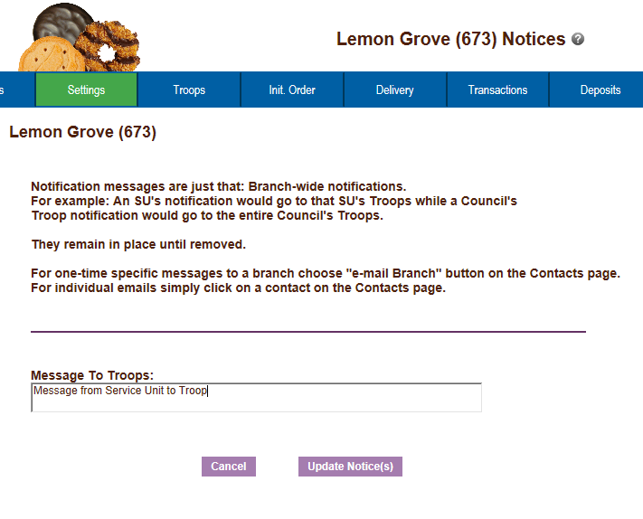

Enter your message to the troops. Click **Update Notice(s)** to activate the message. Click **Cancel** to cancel any changes you made to this screen.

**NOTE:** If you do not want a message to be displayed, you can delete the contents of the message and click update notices and a blank message will show on the troop’s dashboard.

### Edit Calendar Events

You can also **Edit Calendar Events**. Click the **Edit Calendar Events** button. The following screen will be displayed. The eBudde™ calendar items are not changeable. However, you can add service unit specific items.

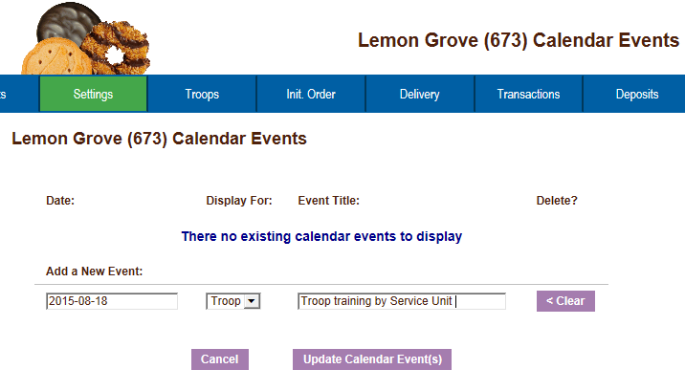

## Troops Tab

To add and/or edit a troop, click the Troops tab on the page. As you add troops, you will see them appear on the left-side of the screen under the **Navigation** tree.

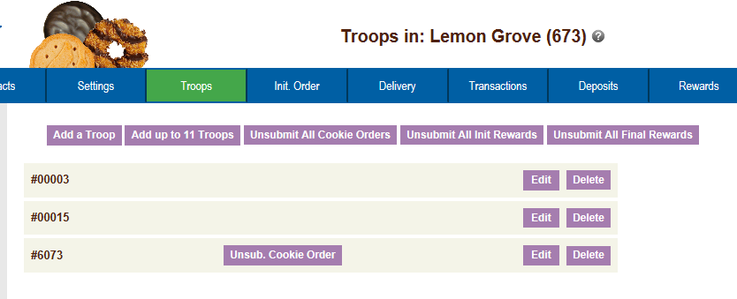

You can enter troops using two different methods. The choice for which button you used is at your discretion.

**Add a Troop** – This button allows you to enter one troop only. You would need to click this button for each troop you entered.

**Add up to 11 Troops** - This button allows you to enter up to 11 troops at a time. If you had 13 troops you would need to click this button twice. The first time you would enter the 11 troops. The second time you would enter 2 troops.

**Unsubmit All Cookie Orders** – This will unsubmit all troop cookie orders if necessary to allow troops to resubmit

**Unsubmit all Initial and Final Reward Orders** - This will unsubmit all troop reward orders if necessary to allow troops to resubmit.

**NOTE:** You can un-submit orders for individual troops if necessary. Once your order(s) are sent to the bakery, these buttons will be removed.

**To Add a Troop** – Left-click the **Add a Troop** button displayed on the page. The following page will be displayed on the page.

## Adding or Editing a Troop

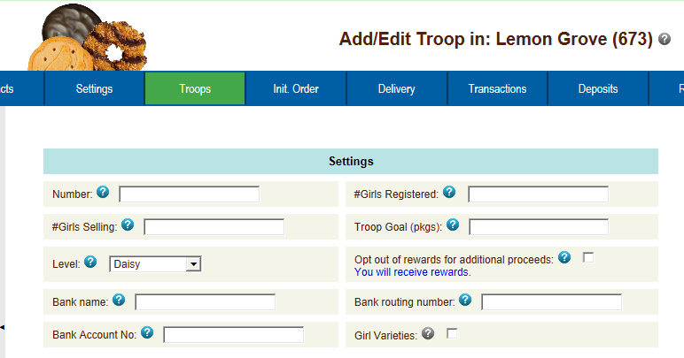

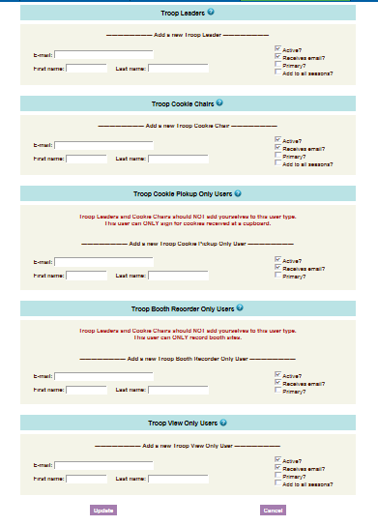

**Number** – enter the troop number

**# Girls Registered** – the number of girls registered in the troop or 0 if unknown (May be inaccessible due to council customization)

**# Girls Selling** – the number of girls selling cookies in the troop or 0 if unknown (May be inaccessible due to council customization)

**Troop Goal (pkgs):** - if the troop set a sales goal, enter the number in packages or 0 if unknown.

**Level:** - Program Age Level of the troop

**Opt out of rewards for additional profit:**- If this troop has the option of not receiving reward rewards and receiving additional monetary funds, click in this box.

**Bank Name (optional)** – *Let the troop enter the data – if we have not uploaded it*

**Bank Routing No. (optional)** – *Let the troop enter the data – if we have not uploaded it*

**Bank Acct No. (optional)** – *Let the troop enter the data – if we have not uploaded it*

**Troop Leader or Troop Cookie Chair or Troop View Only Users:**

* You **MUST** enter an email address for one of the three types of users.

**Email:** -Enter email address

**First name:** (Optional) – Enter in contact’s first name

**Last name:** (Optional) – Enter in contact’s last name

**Active?** – Check this box if you want the contact to have access to the system.

**Receives email?** – Check this box if you want the contact to receive email from you and/or council and the confirmation emails when ordering.

**Primary?** – You may designate a contact as the primary contact in the category. This designation will allow eBudde™ to send primary contact specific emails from council and will be the contact that appear on some of the updated reports.

**Add to all seasons?** – Check this box if you this contact to have access to the troop in previous years.

Left-click **Add** to add the troop. Left-click **Cancel** to leave the page without adding the troop.

## Special Troop Contacts

There are two troop contacts that may be available, Troop Cookie Pickup Only Users and Booth Sale Recorder Only Users.

If your council uses the Cupboard Keeper mobile app, you may specify additional cookie-pickup people which eBudde™ refers to as the Troop Cookie Pickup Only User. For example, if you have a parent picking up cookies for you and your council uses the Cupboard Keeper mobile app, you will need to add this person’s email in eBudde™. This user does not have access to anything in eBudde™ except updating their own contact information. Their email and password will be used by the Cupboard Keeper mobile app to verify that they are allowed to pick up cookies at the cupboard.

**NOTE: As a troop leader or troop cookie chair, you are able to pick up cookies. DO NOT add yourself as a troop pickup person or you will LOSE ACCESS to the other tabs in eBudde™.**

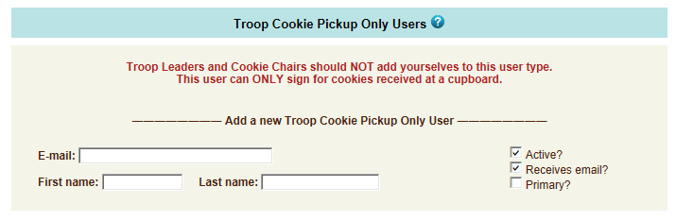

If your council used the Booth Sale recorder mobile app, you may specify additional booth sale recorders users. If you have an adult in charge of the booth site that is not in eBudde™ and you want them to record the booth site sales, you will need to add them in as a Troop Booth Recorder Only User. This will allow them to record the booth sales on the mobile app and/or in eBudde™. They will also be able to change their contact information in eBudde™. They WILL NOT have access to any of the other troop tabs in eBudde™.

**NOTE: As a troop leader or troop cookie chair, you are able to record booth sales. DO NOT add yourself as a troop booth recorder only user or you will LOSE ACCESS to the other tabs in eBudde™.**

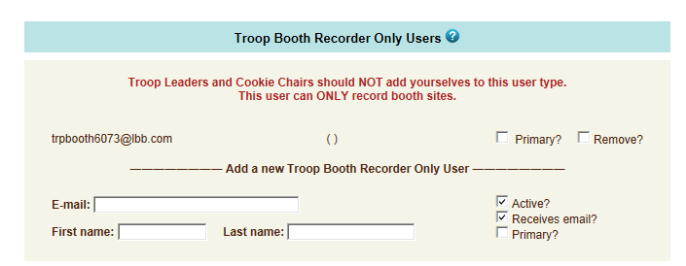

**To Add up to 11 Troops –** Left click the **Add up to 11 Troops** button. The following page will be displayed:

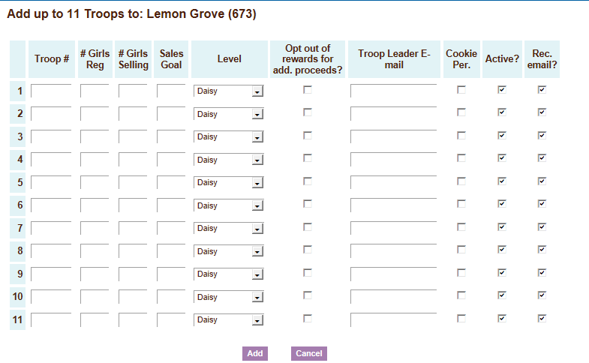

**Troop Number** – enter the troop number

**# Girls Registered** (Optional) – the number of girls registered in the troop (will not be displayed if girl registration automation is turned on)

**# Girls Selling** (Optional) – the number of girls selling cookies in the troop (will not be displayed if girl selling automation is turned on)

**Has Sales Goal:** - if the troop set a sales goal, enter the goal in packages

**Level:** - Program Age Level of the troop

**Proceeds (no rewards):** - If this troop has the option of not receiving reward rewards and receiving additional monetary funds, click in this box.

**Troop Contact E-mail:** – You **MUST** enter an email address here.

**Cookie Per.** – Click the box if the contact email is for the troop cookie person.

**Active - If** this troop contact will be a user on the system, this box must be checked

**Rec Email –** If you want the troop contact email user to received the email confirmations, this box must be checked

Left-click **Add** to add the troop. Left-click **Cancel** to leave the page without adding the troop.

As you add troops, the system will update the navigation tree. You will also be allowed to change and/or delete troop information.

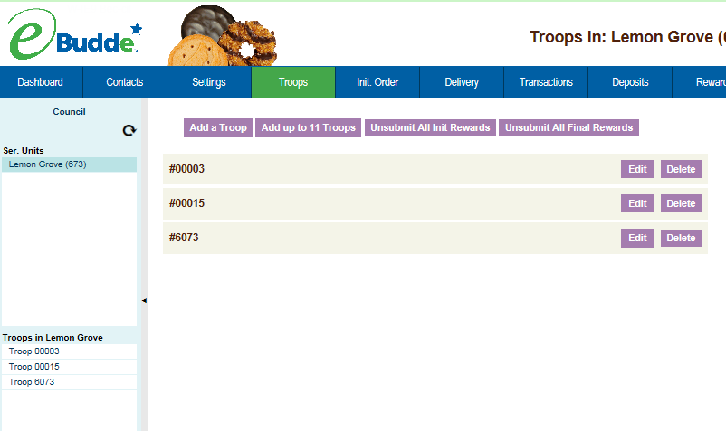

To change troop information or remove a troop, click on the **Troops** tab. The system will list the troops currently in the system.

**Edit** – The edit button allows you to change information about the troop and add new troop contacts.

**Delete** – The delete button allows you to remove the troop from the system. Your council may disallow this capability. *SUs will not be able to delete after the Initial Order (SIO) has been submitted.*

### Deleting the Troop

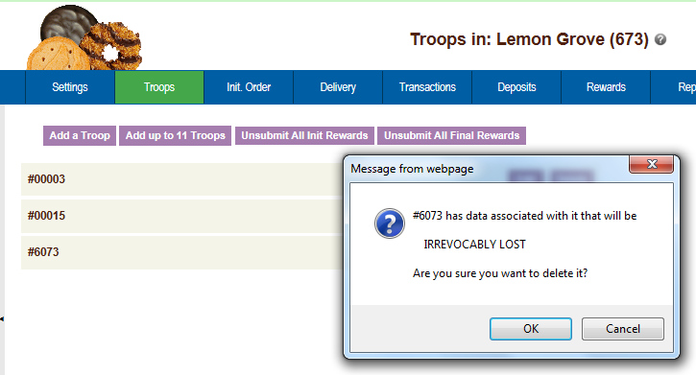

Left-click the Delete button. The eBudde™ system will confirm that you want to delete the troop. Left-click the **OK** button to delete the troop. Left-click the **Cancel** button if you do not wish to delete the troop.

## Un-submitting Troop Orders

Troops will submit their cookie and reward orders. You as a service unit can un-submit one or more troop orders for cookies and rewards. When a troop submits an order of any kind, the appropriate un-submit button will appear in the troop row. The example below shows that the troop submitted their cookie order but not any reward orders.

To un-submit a troop order, find the troop, click the appropriate un-submit button. The system will display messaging that the troop’s order has been unsubmitted.

Keep in mind that deadline dates are still in effect. So, if you un-submit an order after the deadline date for the troop to submit the order, the troop will not be able to re-submit. Also, once you submit orders to council/area, the un-submit button will no longer be available.

**CAUTION: The troop’s order must be re-submitted prior to deadline dates to be included in orders to the bakery.**

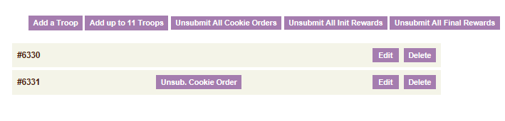

## Init. Order

Format of the screen may be in **Cases** or **Packages** as directed by your council. One or more of the following options may apply for the **initial cookie order**:

* Verify troop orders
* Enter troop orders using the fast entry option
* Enter service unit order
* Submit service unit/troop orders to council

**NOTE: If you will be entering troop cookie orders using the troop cookies tab, see Appendix A.**

### Initial Order Page- Troops placing orders

**Instructions for service units once orders have been placed for troops by troops or the service unit at the troop level**

All orders need to be reviewed by the service unit. The service unit can monitor this entry easily by looking at the initial order page. This page is where you verify the cookie orders by troop, add a service unit order and then submit your service unit orders to the council. Once you have submitted your initial cookie order you cannot change the order. **ONLY** council will be able to change the order at that point.

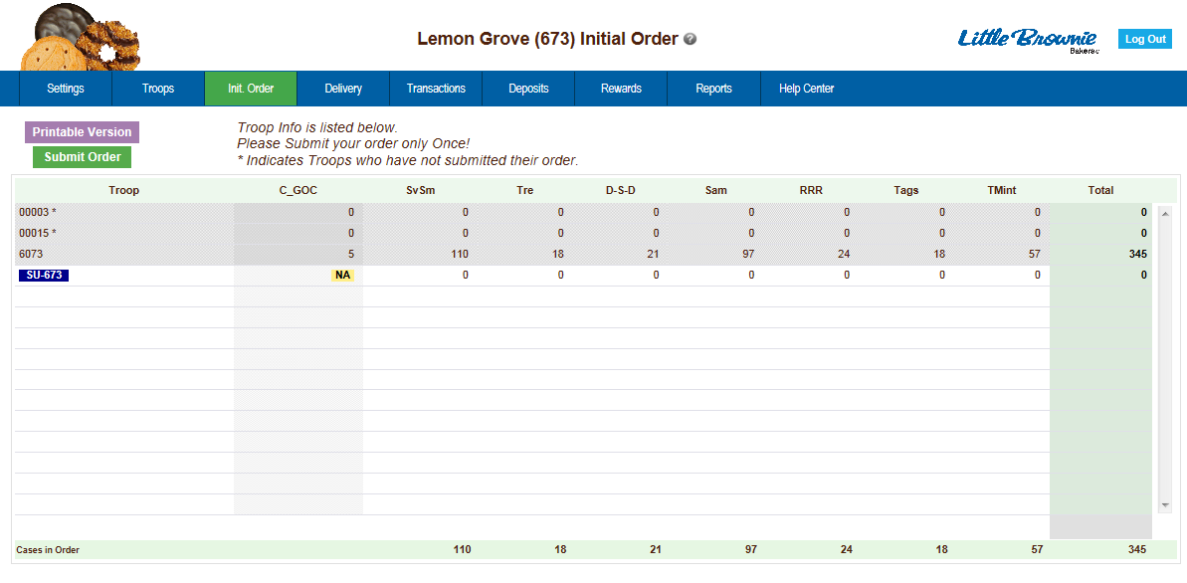

**Printable Version** – Left-click this button to print a report that shows the above information.

**Submit Order** – Left-click this button to submit your service unit order to your council. **NOTE:**  **You can only submit your order ONCE! If a change needs to be made, you will need to call council to make the change to an order.**



The system will display the status of troop orders. In the example above troop 1251 has submitted its order. Troops 00003 and 00015 have not submitted their orders as designated by the **\*** (asterisk).

If your council designates your role to key in a service unit order, you would key that information here. **NOTE: GSGLA does not.**

.

## Delivery Tab

*GSGLA is not using at the Service Unit level, just Troop level (see Troop eBudde Guide).*

## Transaction Tab

This area is used if the service unit needs to record transactions for cookies from the service unit to the troops. ***NOTE: GSGLA does not permit SU orders.***

## Deposits Tab

Council will record Troop ACH debits. Also, if a troop’s debit is returned for any reason – for example, non-sufficient funds (NSF) – those will be recorded here.

### Navigating the Deposit Information Page

The system displays the debits using a scrolling feature.

Scrolling

Debits are displayed n the order keyed by default. You can scroll through the debits pages by using the scroll bar located to the right of the deposit page.

Sorting

You can sort the debits in any order that will be show you the deposits in that particular order.

▼ Sort from smaller or earliest to larger or latest

▲ Sort from larger or latest to smaller or earliest

► Not sorted by this column

Search and Filter

Column Filter – The column filter allows you to search and selectively display by any of the columns available. The default is **No Filter**. This will display all transactions. You use the drop down box to select your search/display column. In the **Low and High** boxes you enter the range that you want to see displayed on the page.

## Rewards Tab

Reward orders are entered at the girl or troop level. The service unit role is to monitor the entry of reward orders and submit the order to the council. Your council may or may not designate that your council will have an initial order.

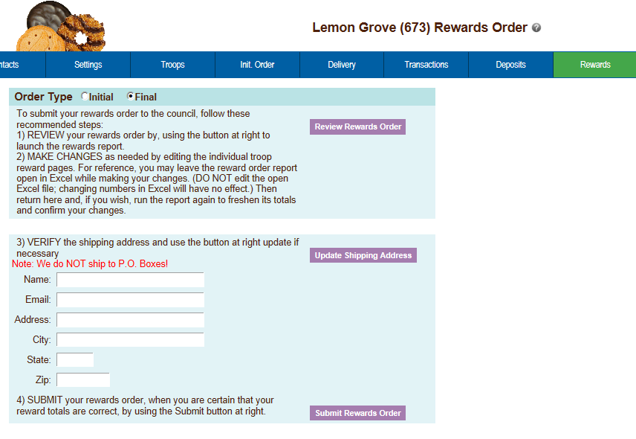

**Order Type** – Initial order type is an option that may or may not be available as it is a council option. If you have both types, you may select which type you will be verifying and submitting to council.

**Review Rewards Order** – This will create a report for the rewards that have been entered into the system. This report can be saved and printed. You **MUST** verify the accuracy of this report before proceeding. If you need to make changes, **DO NOT** make them on the report. Go back to the troop reward order form to make the changes

**Update Shipping Address** – This option may or may not be available. If available, the service unit must enter in the shipping contact name address. This information is used by the bakery warehouse to ship the items to the service unit.

**Submit Rewards Order** – Once all troop reward orders have been verified, click the button. This will send your verified rewards order to council. The system will verify that you want to submit your order. Once you have submitted your order, you will not be able to make any changes, only council will.

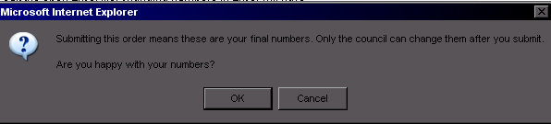

## Booth Sites Tab

The booth sites tab is an optional tab that councils will provide for service units to be able to approve troop requests for booth sites that are not council sites. You can also approve on the troop level, however this allows you to view all your troop requests.

If there are no booth sites to approve/deny, the following message will be displayed

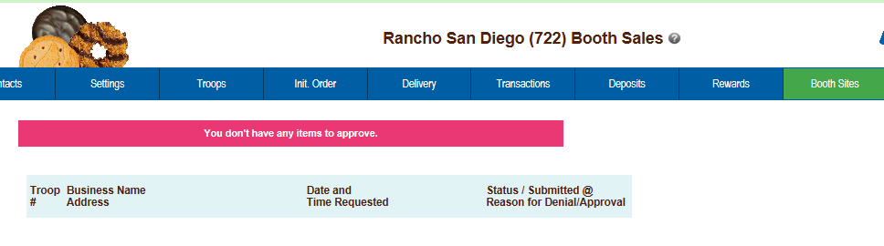

If you have requests to approve/deny, the screen will display as follows:

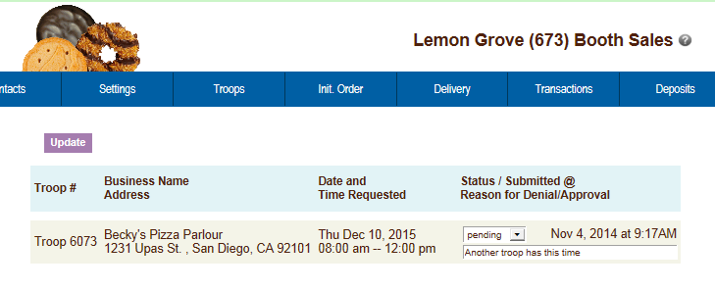

You can approve, deny, make pending by using the drop down box. You can also enter in comments about your selection that is visible to the troop on their level.

If two troops are requesting the same site on the same date and timeframe, you can see who requested the site first by reviewing the date and time under the Status/Submitted column.

## Reports

This section will allow you to print reports for your service unit. We currently have nine reports. New reports will be added to the system. Left-click **View Report** to open the report in a Microsoft Excel downloadable window. All Excel reports will print in XLSX format



Some reports due to the length of time to create my require regeneration. You will click the **Regenerate** button. eBudde™ will tell you that it sent the request to the queue. You will be sent an email when the report is ready. You can then click the **XLSX or PDF** button to print.

The system will display a box to open the report or save it to your computer. The format for both is a Microsoft Excel Worksheet

If you want to know the details of the report, click the link labeled **Descriptions of these Reports**. It will bring up a list of the reports with additional details of information that is on the report and the purpose of the report.

You can now run some reports as **Exportable**. Exportable reports allow you to run reports in a fashion that puts all information in columns to facilitate sorting or simple data dumps. See example below of the service unit recap

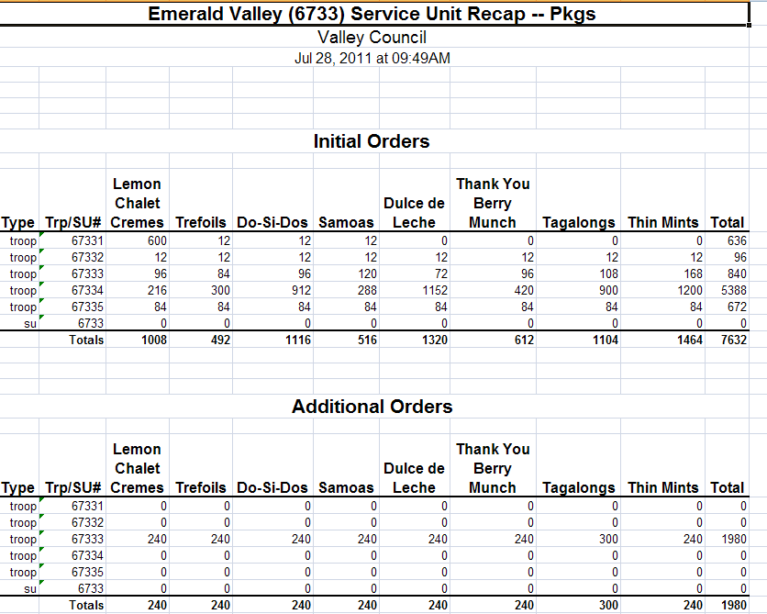

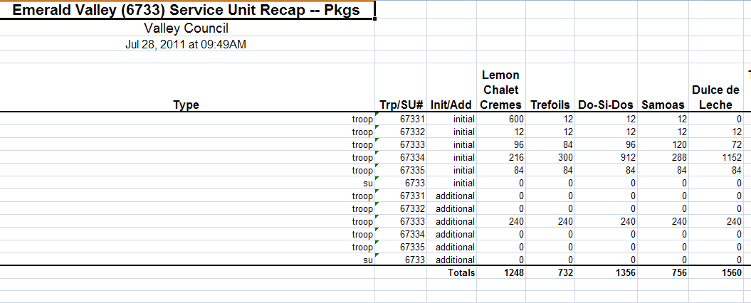

*Exportable Version*

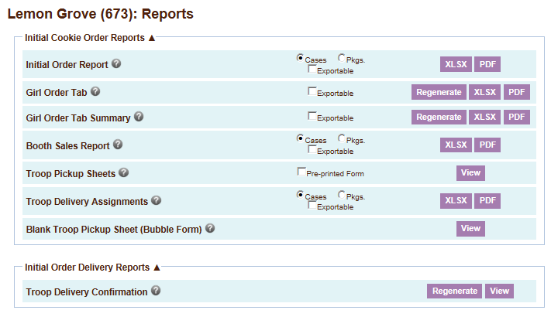

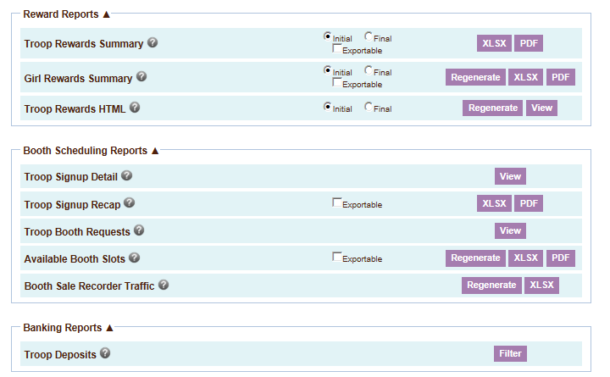

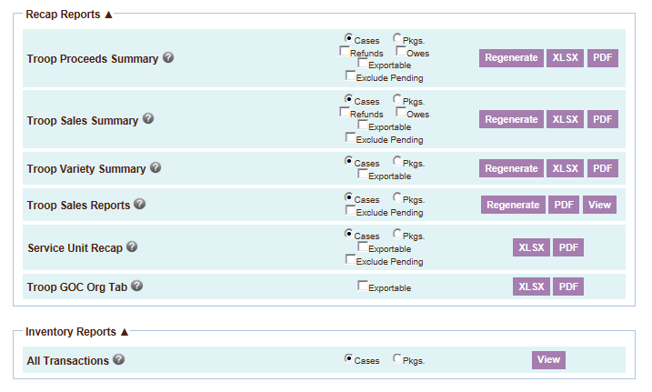

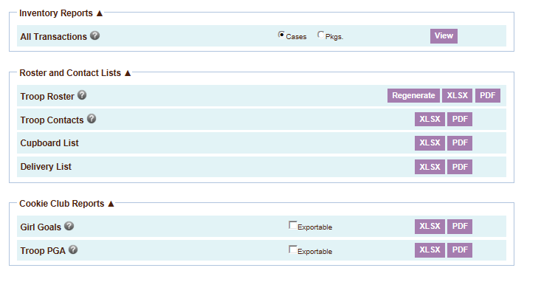

**Initial Order Report** – This report list all troop initial cookie orders by variety. The report can be printed in either cases or packages.

**Girl Order Tab** – This report prints each troop’s girl order tab in detail. It will list all the transactions per girl, per troop.

**Girl Order Tab Summary** – This report prints each troop girl order tab in summary view. It will list each girl and her total orders.

**Booth Sales Report** – This report lists all the troop initial orders that have ordered cookies for booth sales on the troop worksheet. The report can be printed in either cases or packages.

**Troop Pickup Sheets** – These sheets can be printed one of two ways. If you check the pre-printed form, it will print quantities of cookies for each troop that will need to be printed on a form supplied by your council. If you do not check the box, the system will print the entire form in color (must have a color printer) for you.

**Troop Delivery Assignments** – This lists all the troops and their delivery station selection including site, time and line (if applicable)

**Blank Troop Pickup Sheet** – This will print a pickup sheet with no information on it. You can use this report as a fill-in pickup sheet.

**Troop Delivery Confirmation** - Prints the delivery confirmation form in mass that is available on the troop delivery tab

**Troop Rewards Summary** – This report allows you to print a reward summary for either the initial reward order or the final reward order.

**Girl Rewards Summary** – this report prints the reward summary showing every girl in the troop and the troop totals.

**Troop Rewards HTML** – The report prints the troop reward in portrait orientation 8 ½ x 11. Can print on multiple pages if rewards program has a lot of items.

**Troop Signup Detail** – This report show the troops in the service unit that have signed up for council booth sites

**Troop Signup Recap** – This report lists all the troops in the service unit and their total number of signups.

**Troop Booth Requests** – This report shows the requests that troops have made for booth sites not on the council site list.

**Available Booth Sales** – This report shows all the booth slots that have not been taken.

**Booth Sale Recorder Traffic** – This report gives statistics on the use of the booth sale recorder in your service unit This report is only available for users that are booth sale uploader.

**Troop Deposits** – This report will list all deposits for your service unit. It will give you the option for filtering what is on the report.

For all transactions, leave the boxes blank and left-click the **Run Report** button.

**Date** – To print using the date filter you need to enter a date in one or both boxes after the date label. You also need to format the date as mm/dd/yy. Left-click the **Run Report** button to print the records specified

**Range of Dates** - enter in first box the starting date, enter in second box the ending date. This will be an inclusive range displaying all deposits between those two dates and including those two dates.

**One Date –** enter the date in the first box and enter it again in the second box.

This will display all the deposits for that day.

**Starting Date to Last Date Keyed** – enter the starting date in the first box, leave the second box blank.

**All Dates to a Specific Ending Date** – leave the first box blank, enter the ending Date in the second box.

**Troop #** - To print using the troop number filter you need to enter a troop number in one or both boxes after the troop # label. Left-click the **Run Report** button to print the records specified

**Range of Troops** - enter in first box the starting troop number; enter in second box the ending troop number. This will be an inclusive range displaying all deposits between those two troops and including those two troops.

**One Troop –** enter the troop number in the first box and enter it again in the second box. This will display all the deposits for that troop.

**Starting Troop to Last Troop Keyed** – enter the starting troop number in the first box, leave the second box blank.

**All Troops to a Specific Ending Troop** – leave the first box blank; enter the ending troop number in the second box.

**Date and Troop Number –** You can use the combinations listed above to specify deposits by date and/or by troop number.

**Troop Proceeds Summary**  - This report will detail by troop, the cookie initial orders, transfers, final orders, girls registered, girls selling, per girl averages, total sales, troop proceeds, deposits and balance dues. This report can be viewed in packages or cases by clicking the appropriate radial button.

You can also filter this report to show only troops who are due a refund or owe money by check the appropriate box. If no boxes are check, all troops will be displayed.

**Troop Sales Summary** – This report is very similar to the troop proceeds summary. It includes all the items from the troop proceeds summary but also breaks down the troop proceeds into categories if applicable. This report can be viewed in packages or cases by clicking the appropriate radial button.

You can also filter this report to show only troops who are due a refund or owe money by check the appropriate box. If no boxes are check, all troops will be displayed.

**Troop Variety Summary** – This report lists for each troop the total varieties ordered.

**Troop Sales Reports** – This report will print all the troop sales report. The format will be just like the troop sales report tab. Troop banking information will be hashed out except for the last four numbers on this report.

**Troop Sales Report with Bank Information** – This report will print all the troop sales report. Troop banking information will be display as full numbers. This report is only available to users who have Bank Manager Account permissions.

**Service Unit Recap** – This report will show cookie activity for the service unit.

**Troop GOC Org Tab** – This report will print all the Gift of Caring Organizations entered by troops on the troop GOC Org tab. *Not implemented for GSGLA.*

**All Transactions** – This report will list all transactions that a service unit created moving cookies from the service unit to the troop or troop-to-troop transactions.

**Troop Roster** – This report prints the details of the troop settings tab for all troops. No banking information will be on this report.

**Troop Roster with Banks**- This report prints the details of the troop settings tab for all troops including the bank information in full viewing format. This report is only available to users who have Bank Manager Account permissions.

**Troop Contacts** – This report will show you a list of all troop contact name, address and phone number information.

**Cupboard List** – This report will list all available cupboards and their hours of operation.

**Delivery List** – This report will list all available delivery sites for the service unit and location information.

**Girl Goals** - This report compares girl cookies sold against the Cookie Club information

**Troop PGA** – This report shows troop per girl average for troops and compares for Cookie Club troops.

# 

# Appendix – Troop Sales Report

The sales report reflects all transactions for the troop in the system. It includes the initial order, any additional orders, deposits and the calculation for troop profit, council monies and balance due. All Gift of Caring numbers will be pulled from the Girl Order tab. No data entry will be necessary on the Troop Sales Report. Council sponsored Gift of Caring will be displayed under Packages Received. Troop Gift of Caring boxes will be displayed on the right under PGA Registered.

